**Curriculum Vitae**   
Name: **Adepitan William**   
Location: 138 Windsor Road, Wellingborough, NN8 2NB  
Email: demi.adepitan@gmail.com   
Phone Number: +44 7349 854024

### Objective

I’m a passionate and determined student looking for an apprenticeship in Game Development. My dream is to become a gaming entrepreneur—crafting immersive experiences that inspire and entertain. I’m eager to gain hands-on experience, support creative teams, and sharpen my technical skills.

### Education

**School:** Wollaston School, Wellingborough **Year:** Year 10 **Status:** Currently pursuing GCSEs

### Experience

Fullstack Website Developer (Frontend + Backend)

Transitioned to Game Development to pursue my passion

### Skills

Fullstack Website Development

Game Development with Unity (actively learning)

Frontend & Backend Programming

Creative Problem-Solving

### Hobbies

Listening to music

Playing and analysing games

Reading articles about game mechanics

Designing small prototype projects

### Reason for Apprenticeship

I want to work alongside experienced developers to understand real-world processes, learn new tools, and contribute meaningfully to game projects. I believe collaboration builds better games and better creators.

### ✅ Why I’m the Right Fit

My background in website development taught me how systems work, and that directly helps in game development—especially with command-line tools and understanding technical requirements. My determination is rooted in a childhood dream: to create games that bring joy to others and myself.

### Achievements

STEM Certificate awarded by The Smallpeice Trust during STEM Day  
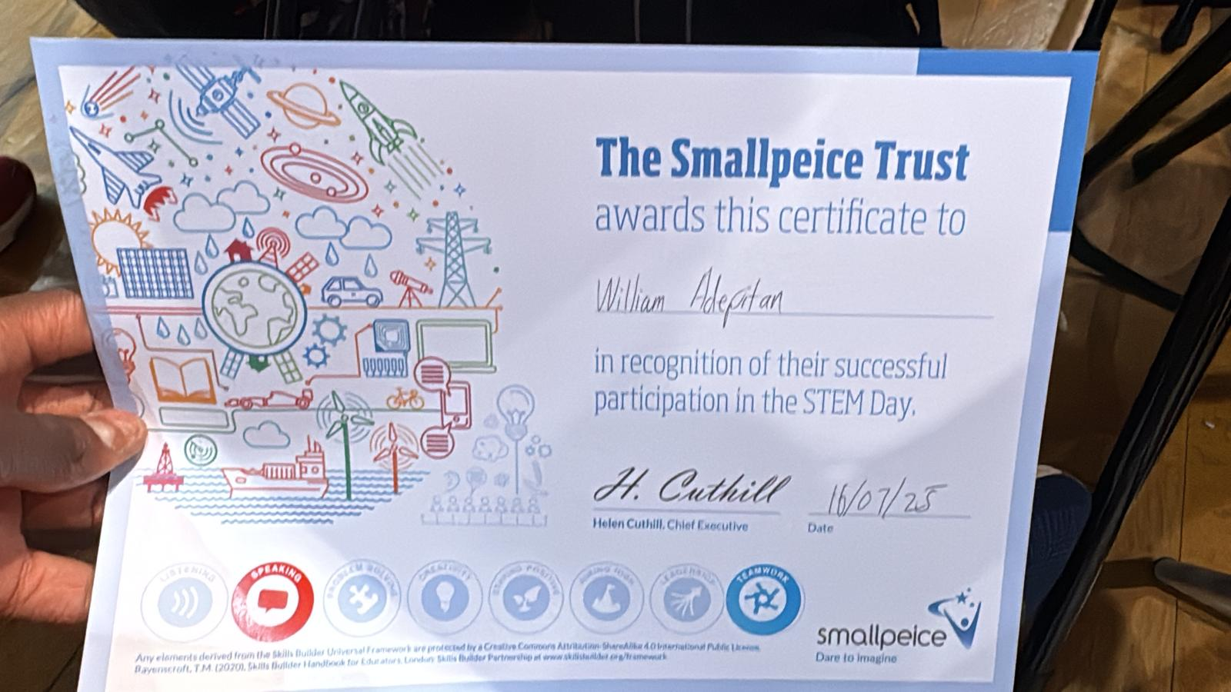

### Final Note

I’m excited to assist, learn from others, and be part of something bigger. Every project is a new opportunity—and I’m ready to grow, contribute, and create.